Name:______________________________________ Date: ____________ Period: ____
Lesson 1.2.8 Problems 1-137 to 1-141
1-137. Rewrite each fraction in at least 2 different ways.
  - b. c. d.

1-138. Jonathan measured 2 cups of flour into a bowl on the counter. Then he spilled part of it, and now there is only cup left. How much did he spill?

1-139. Maggie is making muffins with a recipe that yields 18 muffins.
a. There are 12 people in Maggie’s book club. If the muffins are divided evenly among each person, how much will each person get? Explain your thinking.

Explain: ______________________________________________________________________
_____________________________________________________________________________

b. If Maggie wanted to divide the muffins evenly between the 36 students in her class, how much muffin would each person get? Explain your thinking.

Explain: ______________________________________________________________________
_____________________________________________________________________________
1-140. Multiple Choice: If the probability of getting a particular result in an experiment is 75.3%, what is the probability of not getting that result? Explain your choice.
a.75.3% + 100% b.75.3% − 100% c.100% − 75.3% d.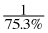

Explain: ______________________________________________________________________
_____________________________________________________________________________

1-141. Throughout this book, key problems have been selected as “checkpoints.” Each checkpoint problem is marked with an icon like the one at left.
For each figure below, find the area and the perimeter.
a. 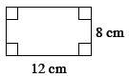 b. 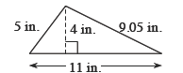

c. 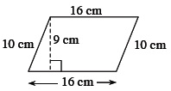 d. 